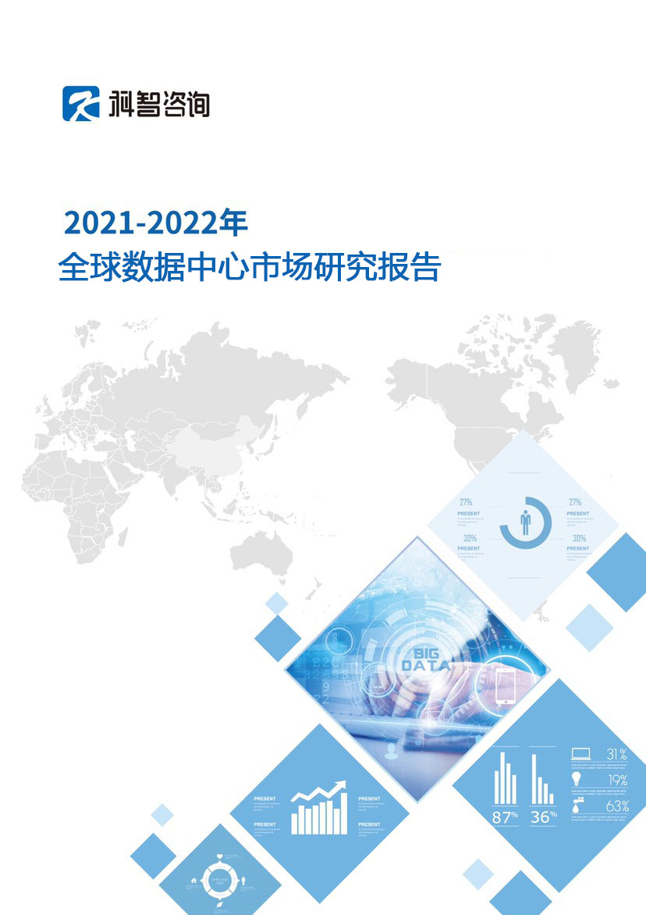
2021-2022
Global Data Center Market Research Report

Declaration

This report is the copyright of Zhongke Zhidao (Beijing) Technology Co., Ltd. and KZ Consulting.

This report is the research and statistical results of KZ Consulting. The nature of it is business information for customers' internal reference, and the data and conclusions only represent views of the company.

This report is provided to the customer who has purchased and it is for internal use only. If the report purchaser wants to publicly reference the data and views in this report, they must submit a written application to KZ Consulting in advance. It could be publicly referenced with the written permission from the KZ Consulting. Report purchasers shall not publicly reference any data and views in the report by any means (including Internet) and shall not provide the report content to any organizations or individuals without the approval, confirmation and written permission from Kezhi Consulting. Otherwise, all the legal consequences caused by the customer shall be borne by the customer. Meanwhile, KZ Consulting retain the right to pursue legal actions against the customer if they also believe that the behavior infringes the copyright of KZ Consulting.

KZ Consulting
Zhongke Zhidao (Beijing) Technology Company Limited

Report Content
Chapter 1 Analysis of Global Data Center Market Development Environment
Session 1 Analysis of Macro Environment for Global Data Center Market Development
1.1.1 Policy Environment Analysis
1.1.2 Economic Environment Analysis
1.1.3 Policy Environment Analysis
1.1.4 Technical environment analysis
Session 2 Analysis of the General Environment of Global Data Center Industry
1.2.1 Overview of Global Digital Economy Development
1.2.2 Analysis of Global Data Center Policy Environment
1.2.3 Analysis of Supporting Basic Resources for Global Data Center Industry Development
Section 3 Evaluation of Global Data Center Industry Development Environment
1.3.1 The Impact of Global Development Environment on the Data Center Industry
1.3.2 Investment Attractiveness of Data Center Market in Key Global Regions
1.3.3 Development Prospects of the Data Center Market in Key Global Regions
Chapter 2 Overview of Global Data Center Market Development
Section 1 Market Scale of Global Data Centers
2.1.1 Scale and Growth of Global Data Center Market
2.1.2 Market Scale of Data Centers in Key Global Regions
2.1.3 Development Characteristics of Global Data Center Market
Section 2 Analysis of Global Data Center Resource Supply
2.2.1 Scale of Global Data Center Resource Supply
2.2.2 Scale of Data Center Resources in Key Global Regions
2.2.3 Analysis of Data Center Resources of Key Global Service Providers
Section 3 Demand Analysis of Global Data Center Market
2.3.1 Characteristics of Global Data Center Market Demand
2.3.2 Analysis of Demand Structure of Global Data Center Market
2.3.3 Analysis of Key Demand Industries in Global Data Center Market
Section 4 Analysis of Supply and Demand in Global Data Center Market
2.4.1 Characteristics of Supply and Demand in the Global Data Center Market
2.4.2 Analysis of Supply and Demand Structure of Global Data Center Market
2.4.3 Analysis on the Development Trend of Supply and Demand in Global Data Center Market
Chapter 3 Analysis of Data Center Market in Key Global Regions
Section 1 Analysis of Asian Data Center Market
3.1.1 Development Environment of Asian Data Center Market
3.1.2 Overview of the Asian Data Center Market
3.1.3 Asia Data Center Market Supply Analysis
3.1.4 Asian Data Center Market Demand Analysis
3.1.5 Asian Data Center Market Forecast and Development Trend
Section 2 European Data Center Market Analysis
3.2.1 European Data Center Market Development Environment
3.2.2 Overview of the European Data Center Market
3.2.3 European Data Center Market Supply Analysis
3.2.4 European Data Center Market Demand Analysis
3.2.5 Asian Data Center Market Forecast and Development Trend
Section 3 North America Data Center Market Analysis
3.2.1 North America Data Center Market Development Environment
3.2.2 Overview of the North America Data Center Market
3.2.3 North America Data Center Market Supply Analysis
3.2.4 North America Data Center Market Demand Analysis
3.2.5 North America Data Center Market Forecast and Development Trend
Section 4 Market Analysis of Data Centers in Other Regions
3.4.1 Development Environment of Data Center Market in Other Regions
3.4.2 Market Overview of Data Centers in Other Regions
3.4.3 Supply Analysis of Data Center Market in Other Regions
3.4.4 Market Demand Analysis of Data Center in Other Regions
3.4.5 Market Forecast and Development Trend of Data Center in Other Regions
Chapter 4 Analysis of Development Prospects and Investment Opportunities of Global Data Center Market
Session 1 Analysis of Macro Environment for Global Data Center Market Development
4.1.1 Analysis of Factors Affecting the Development of Global Data Center Market
4.1.2 Analysis of Development Opportunities in Global Data Center Market
4.1.3 Analysis of Factors Hindering the Development of Global Data Center Market
Session 2 2022-2024 Global Data Center Market Forecast
4.2.1 2022-2024 Global Data Center Market Scale Forecast
4.2.2 2022-2024 Global Data Center Resource Supply Forecast
4.2.3 2022-2024 Demand Structure Forecast for Global Data Centers
Section 3 Analysis of Investment Opportunities in Global Data Center Market
4.3.1 Investment Environment Assessment of Data Center Industry in Key Global Regions
4.3.2 Analysis of Investment Opportunities in Data Center Industry in Key Global Regions
4.3.3 Investment Risk Analysis of Data Center Market in Key Global Regions
Appendix: Report Instruction

Purchase Notes:

If you want to know the full report content, please contact the account manager of China IDC Quan to purchase.

Contact Person: LIU Xiao (刘潇)
Contact Number: +86 156 3371 6726
Email: rookie.l@idcquan.com

